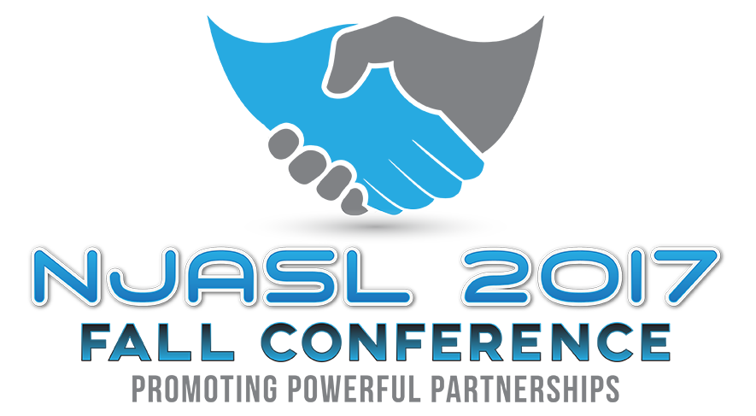
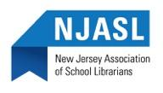
Thursday, November 16, 2017 - Friday, November 17, 2017
Ocean Place Resort and Spa, Long Branch, NJ
Dear Exhibitor,
It is a pleasure to extend to you this invitation to reserve your spot at the New Jersey Association of School Librarians Annual Fall Conference. Each year we invite vendors to display their products for New Jersey’s school library media specialists, public librarians, administrators, and educators. If you have attended our conferences in the past, you know that all the attendees leave our gathering informed, enlightened and enthused.
Our conference will be held at the Ocean Place Resort & Spa on November 16-17, 2017. Although we are still in the beginning stages of planning various activities, for now we have planned a half hour between sessions, Vendor Bingo (which was popular in the past), Raffle drawings, Concession breakfasts and lunch, and Coffee/Tea plus other activities that will have your area busy with the approximate 500 attendees! A more detailed schedule will be forthcoming.
We encourage you to be part of our conference and invite you to have our attendees learn about your company’s products and services by setting up an exhibit, sponsoring an event, advertising in our program, and donating an item to the raffles. We are anticipating many new vendors this year. Spaces are assigned on a first-received basis as well as sponsorship status.
CONFERENCE 2017 EXHIBIT SPACE APPLICATION
A receipt for your reservation and additional information about drayage, booth assignments, telephone lines, electrical hookups, etc., will be sent to you in the fall.

Please reserve the following exhibit space:
Booth(s) @ $500.00 each ___________
Tables(s) @ $350.00 each __________ Amount Enclosed: _____________________

FULL NAME and ADDRESS of VENDOR: PLEASE PRINT ALL INFORMATION

Company Name: __________________________________________________ Representative Name: ________________________________________
Company Address: _______________________________________________
Company Phone: _________________________________________________ Representative Email: _________________________________________
Other Representative Names and Email (List on back if necessary):

_________________________________________________________________________________________________________________________________________________

Person’s Name/Email/Phone for receipt/information:

_________________________________________________________________________________________________________________________________________________

Type of Material to be exhibited (Please check all that apply to be listed in the conference program)
____ Books ____ Periodicals ____ Furniture
____ Hardware/AV ____ Online Databases ____ Hardware/Computer
____ Automation systems ____ Reference Books ____ CD / DVD
____ E-Books
____ Other: _________________________________________________________________

TABLE/BOOTH SIGN SHOULD READ: (PRINT)____________________________________________________________________________________________

Interested in presenting a User Group Session? ____yes ____no (will be assigned as session space is available)

DEADLINE FOR RESERVATION (and to be in program book): October 6, 2017
Please return this application form with your check to:
Leslie Blatt, P.O. Box 1460 Springfield, NJ 07081
MAKE CHECKS PAYABLE TO: New Jersey Association of School Librarians (NJASL)
Leslie Blatt, Exhibits Chair
973-951-4152 (cell)
MrsLes@aol.com

