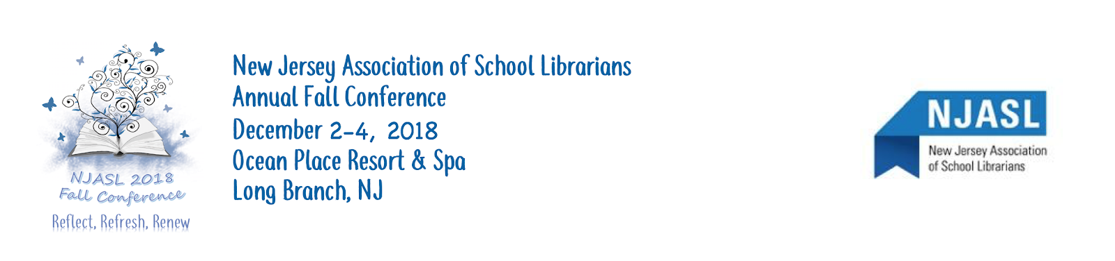

July 2018
Dear Exhibitor:
The New Jersey Association of School Librarians (NJASL) will hold its annual conference on Sunday, December 2nd to Tuesday, December 4th at the Ocean Place Resort and Spa in Long Branch. At that time, over 500 school librarians and many of their administrators come together to hear various speakers address the current issues in school libraries.
Since many of these school library media specialists do the purchasing for their media centers, this is an excellent opportunity for your company to be visible to them. This is a great opportunity for your company to support the school librarians of New Jersey as you introduce and/or reacquaint your company with our important buying power. Therefore, we are inviting you to take this opportunity to be a corporate sponsor for the conference.
Please see the attached pages to choose your sponsorship level and the event/item you would like to sponsor.
Sincerely,
Amy Rominiecki
Direct all correspondence to:
Amy Rominiecki, 2018 Corporate Sponsors Chair
amyrominiecki@juno.com 45 Nevada Avenue Cherry Hill, NJ 08002
------------------------------------------------------------------------------------------------------------------------------------------------
Return this portion with your payment and accompanying documents by Saturday, October 13, 2018.
Please include:
______ Emailed color logo for NJASL’s website
______ Emailed print ready ad for the conference booklet
______ Platinum sponsorship -
Full page, camera ready, color for inside front cover or outside back of cover
______ Gold sponsorship - Full page, camera ready, black and white
______ Silver sponsorship - Advertising inserts
______ Emailed a 30-50 word company description
______ Check made payable to NJASL
DEADLINE: Saturday, October 13, 2018

Company Name: Representative Name:
Company Address: Representative Phone:
Company Phone: Representative Email:
Sponsorships
All levels of sponsorship (excluding Brass) will include:
- Company name listed in the conference program
- Sign at your booth recognizing level of sponsorship. Booth assignments will be placed according sponsorship level.
- Logo on the front page of the NJASL Website AFTER the Conference concludes & will stay posted until the next Conference.
- Signs acknowledging sponsorship at the entrance to the sponsored function.
Platinum $3,000  All sponsorship recognition PLUS:  - Full page advertisement appearing on the outside back cover or inside cover of the conference booklet distributed to all conference registrants. The sponsor will provide a camera-ready ad to NJASL in time for the designated program publication deadline.  - Two representatives invited to attend your sponsored event as guests.  - Booth will be included at no cost to the sponsor. | Platinum sponsorship opportunities:  Keynote Speaker - Shannon Miller _____  Keynote Speaker - Candace Fleming _____  Keynote Speaker - Eric Rohmann _____  Program Book Printing _____  Audio Visual _____
Gold $2,000  All sponsorship recognition PLUS:  - Advertising insert, provided by the sponsor, to be placed in the conference packet given to each registrant.  - One full-page advertisement in the conference booklet distributed to all registrants. The sponsor will provide a camera-ready ad to NJASL in time for the designated program publication deadline. | Gold sponsorship opportunities:  Author’s Panel Luncheon on Monday _____  NJASL Engagement Roundtable on Monday _____  Coffee/tea in Exhibit Hall _____  Future Ready Panel Luncheon on Tuesday _____
Silver $1,250  All sponsorship recognition PLUS:  - Advertising insert, provided by the sponsor, to be placed in the conference packet given to each registrant. | Silver sponsorship opportunities:  Exhibitor/Author’s Alley Grand Opening _____  Saturday Evening Reception  (committee chairs and special guests) _____  Enthusiastic Reader Award Luncheon & Gifts _____
Bronze $ 750  - All sponsorship recognition as listed above | Bronze sponsorship opportunities:  Conference Folders _____  Conference Printing _____  Nursery Rhyme Mystery Dinner  on Sunday Evening _____  Workshop Speaker _____
Copper $ 500  - All sponsorship recognition as listed above | Copper sponsorship opportunities:  Outstanding School Library Media Specialist  of the Year Award _____  Jean E. Harris  Progressive School Library Media Award _____
Nickel $ 250  - All sponsorship recognition as listed above | Nickel sponsorship opportunities:  Signage _____  Special Gifts _____  Conference Pens _____
Brass (literature advertising only) $ 100 | Send Literature for Conference Folder or on Table _____

