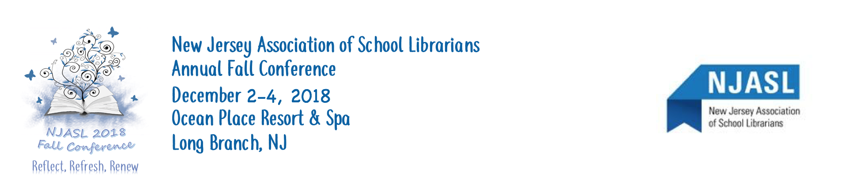
CONFERENCE 2018 EXHIBIT SPACE APPLICATION
A receipt for your reservation and additional information about drayage, booth assignments, telephone lines, electrical hookups, etc., will be sent to you in the fall.

Please reserve the following exhibit space:
Booth(s) @ $550.00 each ___________
Tables(s) @ $400.00 each __________ Amount Enclosed: _____________________

FULL NAME and ADDRESS of VENDOR: PLEASE PRINT ALL INFORMATION

Company Name: __________________________________________________
Company Address: ____________________________________________________
Company Phone: ________________________________
Representative: _________________________________________________ Representative Email: _________________________________________
Other Representative Names and Email (List on back if necessary):

_____________________________________________________________________________________________

Person’s Name/Email/Phone TO RECEIVE FURTHER INFORMAION:

_____________________________________________________________________________________________

Type of Material to be exhibited (Please check all that apply to be listed in the conference program
____ Books ____ Periodicals ____ Furniture
____ Hardware/AV ____ Online Databases ____ Hardware/Computer
____ Automation systems ____ Reference Books ____ CD / DVD
____ E-Books ____ Makerspace
____ Other: _________________________________________________________________

TABLE/BOOTH SIGN SHOULD READ:
(PRINT)_______________________________________________________________________________________

Interested in presenting a User Group Session? ____yes ____no (will be assigned as session space is available)

DEADLINE FOR RESERVATION (and to be in program book): October 13, 2018
Please return this application form with your check to:
Leslie Blatt, c/o NJASL, P.O. Box 1460 Springfield, NJ 07081
MAKE CHECKS PAYABLE TO: New Jersey Association of School Librarians (NJASL)
Leslie Blatt, Exhibits Chair
973-951-4152 (cell)
MrsLes@aol.

