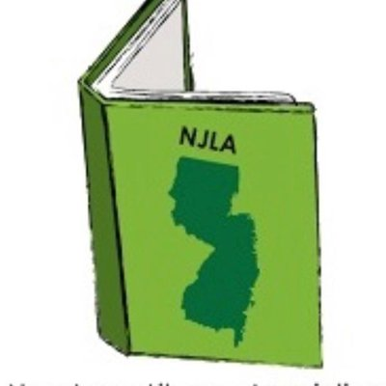

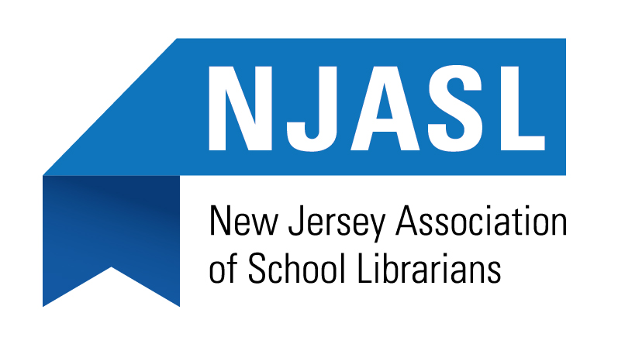

**ENTHUSIASTIC READER AWARD 2018**

This certifies that (Student’s Name) ______________________________________ has successfully met the criteria for the New Jersey Association of School Librarians’ ENTHUSIASTIC READER AWARD - 2016 at the school or public library level.

|  |  |  |  |  |
| --- | --- | --- | --- | --- |
| Student’s Home Address: |  |  | Home Phone: |  |
| Student’s City & Zip: |  |  | Grade: |  |

|  |  |  |  |  |
| --- | --- | --- | --- | --- |
| Name of School or Public Library: |  |  | Telephone |  |
| School or Library Address: |  |  | Library fax: |  |
| City & Zip: |  |  | E-mail: |  |
| School District: |  |  | County: |  |

Permission Slip:

We give the NJASL permission for the following:

1. Enter student’s name & reason why they should be named a 2018 ENTHUSIASTIC READER
2. Use student’s name and photograph for promotional activities in regard to the NJ Association of School Librarians’ activities celebrating literacy and lifetime reading.

|  |  |  |
| --- | --- | --- |
| Teacher or librarian submitting student’s name *(please print)*: |  | ❑ Librarian  ❑ Teacher |
| Principal *(please print)*: |  | |
| Superintendent *(please print)*: |  | |
| Parent’s Name *(please print)*: |  | |
| Parent’s Signature: |  | |
| Parent’s email address: |  | |

Please complete this form and attach your submission why the student is an enthusiastic reader based on the criteria.

Mail to: ENTHUSIASTIC READER AWARD

c/o Leslie Blatt

35 Astor Place

Springfield, NJ 07081

Deadline: Must be postmarked by October 15, 2018